# Welcome to the Richmond WMC Darts Section

We welcome all new players to join our section, from beginners to social or experienced competitors including male, female and juniors.

Our section uses Monday nights as our Section night, which is when we get together to play either social darts or for our internal section Trophies. Also any discussion about any darts related matters for our section etc can be shared. Monday night darts start at 7;30pm with names in by 7;15pm with a $4 entry fee.

Section membership subscriptions are $30.00, which includes $15.00 subscription to the Canterbury Combined Clubs Darts Association, who run weekly interclub competitions on Wednesday nights. This association also has a variety of competitions including Canterbury area championships and representative matches that are normally played on Sundays.

At present our section has 8 four person teams in the Interclub Winter Competition, from 1st grade through to 2nd reserve grade.

We have 6 dartboards in the main bar (Taproom) and 8 extra dartboards are being put up in the social hall (Junction) to allow extra teams or competitions.

We as a section also fundraise to keep the costs to our players, playing darts down.( eg. Tournament entry fees and travel etc.. One of these functions is a weekly lotto number raffle @ $2.00 per number, if interested contact any of the numbers below.

Over the years we have had several players that have played at national and international events representing New Zealand, which can be a goal for those more competitive minded.

Once again welcome to the Richmond WMC Darts Section.

Contacts for more info;

Chairperson; Mike Keenahan 021 163 2924

Secretary/Treasurer; Bill Sansom 027 8199743

Club Captain; Preston Ridd 021 054 1942

g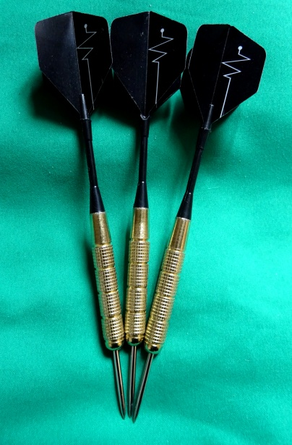ggg

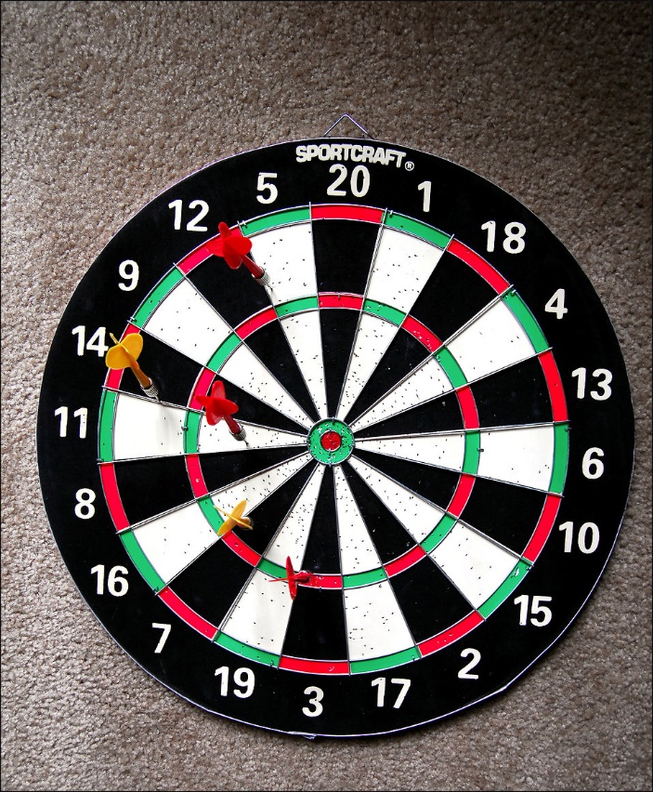

[This Photo](http://www.freestockphotos.biz/stockphoto/17750) by Unknown Author is licensed under [CC BY](https://creativecommons.org/licenses/by/3.0/)

0